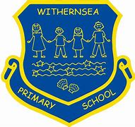
Withernsea Primary School
Long Term Reading Overview 2022-2023

Year Group | Autumn Term |  | Spring Term |  | Summer Term
FS1 |  |  |  |  | Phonics RWI
Becoming familiar with traditional tales & highly/ predictable patterned language. | Story Time Texts |  | Storytime Texts |  | Storytime Texts
 | Nursery Rhymes and Poetry |  | Nursery Rhymes and Poetry |  | Nursery Rhymes and Poetry
FS2 | Phonics RWI |  | Phonics RWI |  | Phonics RWI
Becoming familiar with traditional tales & highly/ predictable patterned language. | Story Time Texts |  | Storytime Texts |  | Storytime Texts
 | Nursery Rhymes and Poetry |  | Nursery Rhymes and Poetry |  | Nursery Rhymes and Poetry
Y1 | Phonics RWI |  | Phonics RWI |  | Phonics RWI
 | RWI Phonics as Needed |  | RWI Phonics as Needed |  | RWI Phonics as needed
Y2- AM sessions | Introduce terminology- predict, retrieve etc. Reading working wall.  Extracts- Comprehension Ninja, Testbase | 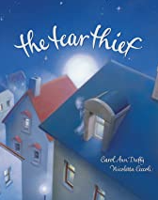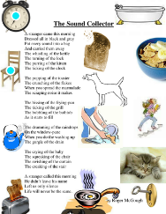 | 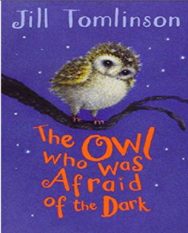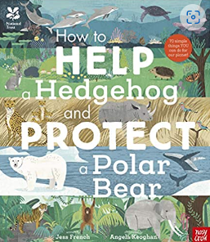 |  | 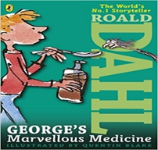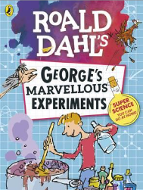
PM Sessions-responding in different ways (RFP) | Fables  Look at a range. retelling, exploration of language and themes | Look at Anthony Browne  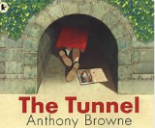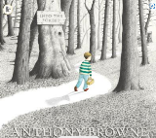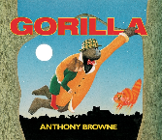 | Introduce terminology- predict, retrieve etc. Reading working wall.  Extracts- Comprehension Ninja, Testbase | Look at Oliver Jeffers  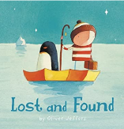  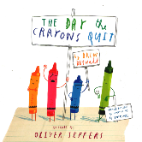 | 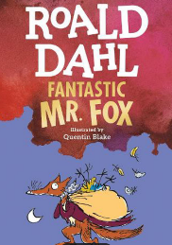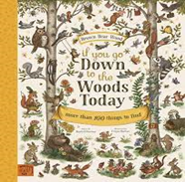
 | Additional Texts to compare: |  | Additional Texts to compare:  The owl who was afraid of the dark picture book version  Owl babies  Be Brave Little Penguin |  | Additional Texts to compare:  Extracts from The Twits to compare characters  The Enormous crocodile- the Villain always loses in the end!
 | Additional Non – Fiction to build schema | Poetry  What am I like? Joshua Seagal  ‘The Cheetah and the Sloth’ Play  The sound collector | Additional Non – Fiction to build schema  Owl facts  Other nocturnal animals | Poetry  Twinkle Twinkle- Jane Taylor  I’m not afraid of the dark  The Star  Little Trotty Wagtail  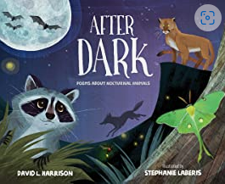 | Additional Non – Fiction to build schema  Animal homes extract  Living on a farm  Witches from other stories (Fairy tales)  Medicines  Things typically found around the home | Poetry/ Play  A verse from The Witches Spell - Macbeth  On the Ning Nang Nong- Spike Milligan  Readers’ Theatre throughout book.
Y3 | 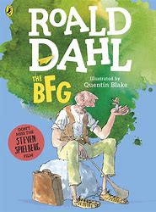  (Review text for next year) |  | 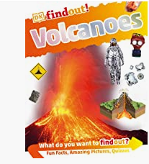  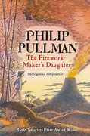 |  | 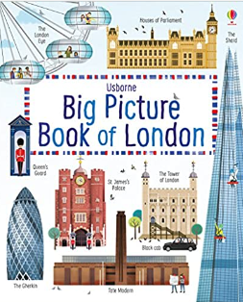  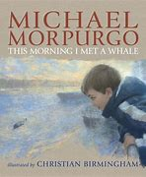
 | Other books for bridging themes:  The Tear Thief Carol Ann Duffy  The Dream Givers (Literacy Shed)  The Selfish giant |  | Other books for bridging themes:  The Secret of Black Rock-  The Bear and the Piano  Malala’s magiic pencil (strong female link) |  | Other books for bridging themes:  Window- Jeannie Baker  Dear Greenpeace- Simon James  Varmints
 | Additional Non – Fiction to build schema  Instructions for making a dream catcher  Roald Dahl Biography | Poetry/ Play  Nonsense poems- See The Works (Red Book)  Roald Dahl- Play Script? | Additional Non – Fiction to build schema  Pirates Fact or Fiction  Captain Blackbeard  All about Elephants | Poetry  Firework Night- Enid Blyton  The Magic Box- Kit Wright  How far I’ll go-Moanna.  Speechless- Aladdin | Additional Non – Fiction to build schema  All about Whales  BBC News Article- Whale on the Thames  End plastic pollution  Oceans  Whale Facts  Whaling and pollution  White Egrets | Poetry  The song of the Whale- Kit Wright  Acrostic poem- pollution  The River poem
Y4 | 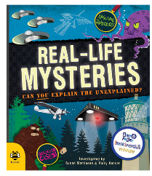  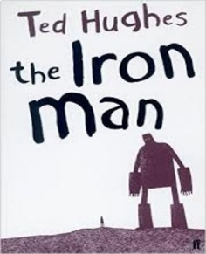  (Y4 box 2) |  | 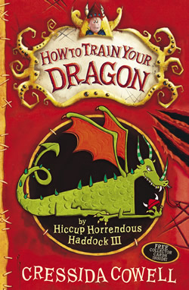  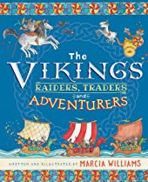  (Y4 Box 1) |  | 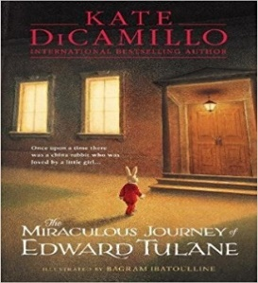  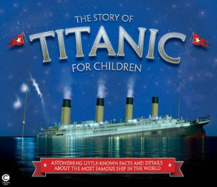  (Y4 Box 2)
 | Other books for bridging themes:  Begu  The Paper-Bag Princess-Robert Munsch- sharepoint  The Wild Robot- Peter Brown  The Iron Woman (extracts)- Ted Hughes |  | Other books for bridging themes:  Short Norse Myths and legends  Odd and the Frost Giants – Neil Gaiman  How to be a Viking- Cressida Cowell  Arthur and the Golden Rope- |  | Other books for bridging themes:  The Incredible book eating boy- Oliver Jeffers  The Selfish Giant- Oscar Wilde  The giving tree  Journey- Aaron Becker  The Velveteen Rabbit
 | Additional Non – Fiction to build schema  Robots - epic  All about Robots- epic  How to be a hero  Iron Man Newspaper report  What is a robot? | Poetry  The coming of the Iron Man  Daffodils- William Wordsworth  Aliens stole my underpants-Brian Moses  The Monster from Outerspace- Pie Corbett  Imagine- John Lennon  Buttons the robot | Additional Non – Fiction to build schema  Viking Longship – Mick Manning & Brita Granstrom  Vikings in 30 seconds – Philip Steele  Vikings and Lindisfarne  How to catch a Dragon- Pie Corbett | Poetry/ Plays  Immigrant Song lyrics – Led Zeppelin  Kennings poetry  Jabberwocky- Lewis Carroll  The Dragon of Death poem  Play- Beowolf? | Additional Non – Fiction to build schema  Ocean Liners- Titanic extracts  On our Street- Our First talk about Poverty https://epic | Poetry  From a Railway Carriage-Robert Louis Stevenson  Ben- Michael Jackson  Read All about it- Titanic Poem  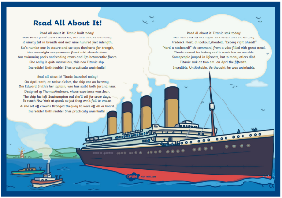
Y5 | 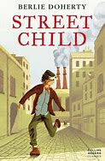  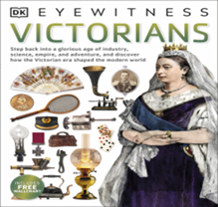 |  | 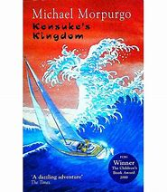  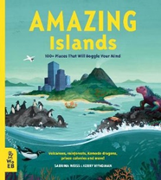 |  | 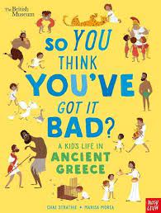  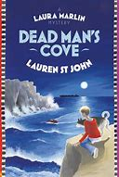  Y4 Box 1
 | Other books for bridging themes:  Oliver Twist- Extracts  Illustrated stories by Dickens- Usbourne |  | Other books for bridging themes:  Flotsam- David Wiesner  The Promise – Nicola Davies |  | Other books for bridging themes:  The London Eye Mystery – Siobhan Dowd (RC)  The Arrival (picture book)  Town is by the Sea  The Secret of Black Rock
 | Additional Non – Fiction to build schema  A school house letter  Dr Barnado- Biography  The Victorians- lives of the rich and poor  Workhouses  The Victorian Era  Escaping the Workhouse  Queen Victoria  Worst jobs for kids | Poetry  What has happened to Lulu-Charles Causley  Oliver! Lyrics | Additional Non – Fiction to build schema  Nagassaki- War in Japan  The Atomic Bomb  Basking Shark  Jelly Fish Facts | Poetry  The Inchcape Rock- Robert Southey  Sea Fever-  The Sea- Brian Procter | Additional Non – Fiction to build schema  Text on coastal smugglers  The Cave (short story)  Extracts linked to The Greeks topic | Poetry/ Play  The Listeners _Walter Del La Mere  The Cave Poem  Smuggler’s Song-Rudyard Kipling  The Highwayman-Alfred Noyes  Greek Plays- See FM
Y6 | 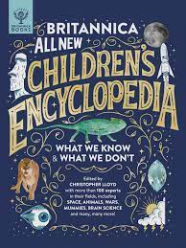  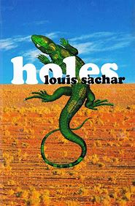  Y6 Box 3 |  | 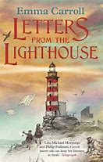  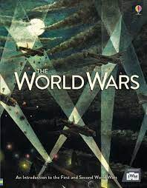  Y5 Box 1 |  | 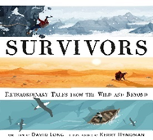  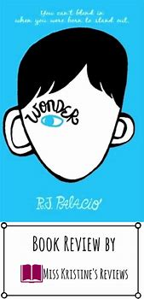  Y6 Box 3
 | Other books for bridging themes:  Journey |  | Picture books/texts for bridging themes:  Rose Blanche – Ian McEwan  The Lion and The Unicorn – Shirley Hughes  Our Castle by the Sea – Lucy Strange (RC)  When Hitler stole pink rabbit - Judith Kerr (RC) |  | Other books for bridging themes:  Itzhak: A boy who loved the violin - Tracy Newman  The Lion Above the Door – Onjali Q Rauf  Voices in the Park  El Defo – Picture book hearing difficulty  I talk like a river
 | Additional Non – Fiction to build schema  Extract from Rosa Parks.  Young Gifted and Black  Information text about American juvenile detention centres.  Bizarre Laws  Historical Punishment | Poetry  The Raven –Edgar Alan Poe  (read the poem and unpick then watch Simpsons episode)  If by Rudyard Kipling  The Road not taken by Frost, | Additional Non – Fiction to build schema  Evacuation extract war  First news fleeing persecution  Information text on lighthouses | Poetry  In Flanders Fields  Rocca San Giovanni  Tea at Oliver’s  Wish me Luck  Click of the Garden Gate  Death of a Hero  Home coming | Additional Non – Fiction to build schema  Shakesphere  The Globe  Plays of the time- tragedy/ farce/ etc. | Poetry/ Plays  When you pass me on the Street –  This is me lyrics – The Greatest Showman  Shakesphere Unit:

