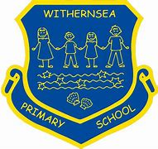
Withernsea Primary School
PE Long term plan 2022/23

 | Autumn 1 | Autumn 2 | Spring 1 | Spring 2 | Summer 1 | Summer 2
Year 1 | Gym  (movement and balance) | Dance | Multi skills 1  (team games) | Dance | Ball skills  (hands) | Sports Day practise
Year 2 | Gym  (movement and balance) | Dance | Circuit | Multi skills 1  (team games) | Multi skills 2  (passing games) | Sports Day practise
Year 3 | Gym | Tennis | Box2Bfit | Netball | Dance | Cricket/rounders | Sports Day Practise
Year 4 | Dance | Basketball | Gym | Tag Rugby | Kurling/boccia | Swimming
Year 5 | Tennis | Netball | Swim catch up/Box 2 b fit | Gym | Cricket | Dance
Year 6 | Basketball | Dance | Tag rugby | Box2bfit | Tri golf | Striking and fielding-rounders/Yoga
PE sessions Outdoor Games sessions

